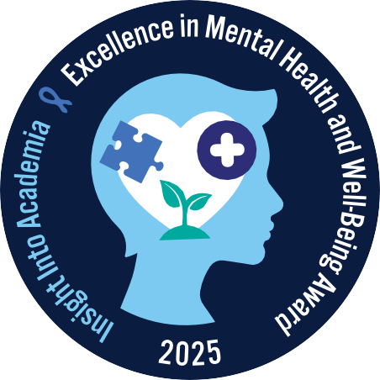

(INSERT INSTITUTION’S NAME AND PROGRAM TITLE) Receives Insight Into
Academia Magazine’s 2025 Excellence in Mental Health and Well-Being Award

National recognition of institutions that commit to campus-wide integration of mental health initiatives, including accessible services, peer support, emotional resilience, and proactive policy.
(INSERT CITY AND DATE)—Today, (INSERT YOUR INSTITUTION’S NAME AND PROGRAM
TITLE) received the 2025 Excellence in Mental Health and Well-Being Award from Insight Into Academia magazine, the largest and oldest diversity and inclusion publication in higher education. The Excellence in Mental Health and Well-Being Award is a measure of an institution’s individual programs and initiatives that significantly advance the core values
of inclusive excellence and belonging through programs, initiatives, and many other campus priorities deserving of this national recognition.

(INSERT INSTITUTION’S NAME) will be featured, along with 70 other recipients, in the September 2025 issue of Insight Into Academia magazine.

(INSERT A QUOTE FROM AN OFFICER OF YOUR INSTITUTION)

Insight Into Academia magazine selected (INSERT INSTITUTION’S NAME AND PROGRAM TITLE) because (PROVIDE SPECIFIC, ADDITIONAL DETAILS ABOUT YOUR PROGRAM).

“We know that institutions are not always recognized for their dedication to their mental health and well-being services and support for their students and employees,” says Lenore Pearlstein, owner and publisher of Insight Into Academia magazine. “We are proud to honor these colleges and universities as role models for other institutions of higher education.”

A call for nominations for this award was announced in March 2025.

For more information about the 2025 Excellence in Mental Health and Well-Being Award, visit insightintoacademia.com.

List of 2025 Excellence in Mental Health and Well-Being Award Winners:

Alamo Colleges District Alvernia University
Arizona State University Baylor College of Medicine Brevard College
Central Connecticut State University Central Michigan University
Claremont Graduate University Colorado State University Pueblo CUNY York College
DePauw University Drexel University
Eastern Illinois University
Edward Via College of Osteopathic Medicine - VCOM
Florida Institute of Technology
Frontier Nursing University
Goucher College
Grand Valley State University
Harper College
Harris-Stowe State University Harvey Mudd College
Hudson County Community College Indiana University
Kennesaw State University Lesley University
Livingstone College
Loyola Marymount University
Macomb Community College
Malcolm X College
Meridian Community College
Miami University
Mississippi State University College of Veterinary Medicine Missouri University of Science and Technology
Molloy University
Montgomery County Community College
Moraine Valley Community College Mount Mary University
Mount St. Joseph University
Nazareth University
New Jersey Institute of Technology Nova Southeastern University Oakland Community College
Orvis School of Nursing, University of Nevada, Reno
Pellissippi State Community College
Pikes Peak State College
Pratt Institute
Ramapo College of New Jersey
Ringling College of Art and Design
Rutgers, The State University of New Jersey Southern Illinois University, Carbondale Southern Oregon University
St. Mary’s University, San Antonio, TX
Stockton University
Student Health, Wellness and Prevention Services, Stony Brook University
SUNY Old Westbury
Syracuse University, Whitman School of Management
Tarrant County College
The University of California, Irvine
The University of Georgia College of Pharmacy
Towson University
University at Albany, State University of New York
University of California, Davis, School of Veterinary Medicine
University of Connecticut
University of Florida College of Veterinary Medicine University of Houston College of Pharmacy
University of Maryland, Baltimore
University of Nebraska College of Law University of Pittsburgh
University of Richmond
University of South Florida College of Nursing
UNM Student Health and Counseling
Upstate Medical University
Wake Technical Community College
Wichita State University

About Insight Into Academia

Insight Into Academia magazine is the largest and oldest diversity and inclusion publication in higher education today. Insight is the leader in recognizing inclusive excellence in higher education through its many prestigious awards, and in advancing best practices in inclusive excellence and belonging through their website and print magazine.

At Insight’s online Career Center, readers will also discover career opportunities that connect job seekers with institutions and businesses that embrace a diverse and inclusive workforce. Current, archived, and digital issues of Insight Into Academia magazine are available online at insightintoacademia.com.

The Leader In Advancing Best Practices In Higher Education Excellence and Belonging

