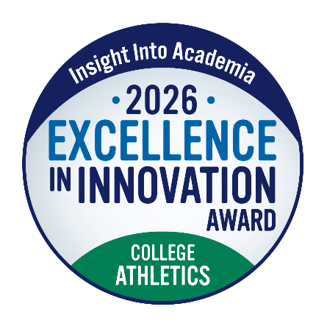

(INSERT INSTITUTION’S NAME AND PROGRAM TITLE) Receives Insight Into
Academia Magazine’s Excellence in Innovation Award: College Athletics

National award recognizes institutions advancing intercollegiate athletics

(INSERT CITY AND DATE)—Today, (INSERT YOUR INSTITUTION’S NAME AND PROGRAM TITLE) received the 2026 Excellence in Innovation Award: College Athletics from Insight Into Academia magazine, the nation’s longest-running publication advancing best practices in higher education.

This new honor celebrates colleges and universities shaping the future of intercollegiate athletics through forward-thinking programs, initiatives, operations, and partnerships. Areas of innovation include support for student-athlete success, NIL (name, image, and likeness) education, sports science, performance, community engagement, technology use, and more.

(INSERT INSTITUTION’S NAME) will be featured in the November 2026 issue of Insight Into Academia magazine.

(INSERT A QUOTE FROM AN OFFICER FROM YOUR INSTITUTION)

Insight Into Academia magazine selected (INSERT INSTITUTION’S NAME AND PROGRAM TITLE) because (PROVIDE SPECIFIC, ADDITIONAL DETAILS ABOUT YOUR EFFORTS).

“The Insight Into Academia Excellence in Innovation Award: College Athletics recognizes colleges and universities turning bold ideas into meaningful progress in intercollegiate athletics,” said Holly Mendelson, co-owner and publisher of Insight Into Academia magazine. “We are proud to honor institutions setting a higher standard for what college athletics can achieve—for student-athletes, campuses, and the fans and communities they serve.”

To see the full list of recipients of the 2026 Insight Into Academia Excellence in Innovation Award: College Athletics, visit InsightIntoAcademia.com.

About Insight Into Academia
For more than 50 years, Insight Into Academia has empowered higher education leaders by defining and advancing the best practices shaping the future of the academy. Across its magazine, podcast, webinars, awards, and digital platforms, Insight spotlights the institutions, initiatives, and ideas driving progress across higher education. Through thought-provoking articles, expert advice, valuable resources, and in-depth profiles of top programs, Insight helps higher education understand what’s working and what comes next. Recognition by Insight Into Academia reflects leadership, innovation, and a commitment to evidence-based excellence. To learn more, visit www.Insightintoacademia.com

